**Kubernetes (k8s) 搭建过程**

1. **安装要求**

**在开始动手之前，安装搭建 kubernetes 集群机器需要满足以下几个条件：**

✬一台或多台机器，操作系统 CentOS7.x-86_x64。

✬硬件配置：2GB或更多RAM，2个CPU或更多CPU，硬盘30GB或更多。

✬可以访问互联网，需要拉取镜像，安装软件。

✬禁止 swap 分区。

|  |  |  |  |  |  |
| --- | --- | --- | --- | --- | --- |
| **角色** | **IOS** | **CPU** | **Memory** | **Disk** | **IP** |
| **Master** | CentOS Linux 7 | 4 cores | 4G | 100G | 192.168.59.133 |
| **Node1** | CentOS Linux 7 | 4 cores | 5G | 100G | 192.168.59.134 |
| **Node2** | CentOS Linux 7 | 4 cores | 5G | 100G | 192.168.59.135 |

**安装三台虚拟机，如上的硬件配置规划，将可以搭建一套单master集群。**

**Operating System:** CentOS Linux 7 (Core)

**Kernel:** Linux 3.10.0-862.el7.x86_64 **Architecture:** x86-64

# cat /etc/redhat-release

CentOS Linux release 7.9.2009 (Core)

echo “127.0.0.1 $(hostname)” >> /etc/hosts

1. **kubeadm 部署方式介绍**

**Kubeadm** 是官方社区推出的一个用于快速部署kubernetes集群的工具，这个工具能通过两条指令完成一个kubernetes集群的部署：

1. 创建一个Master节点 kubeadm init
2. 将Node节点加入到当前集群中 kubeadm join <Master 节点的 IP 和端口>
3. **最终目标**
4. 在所有节点上安装 Docker 和 kubeadm
5. 部署 kubernetes Master
6. 部署容器网络插件
7. 部署 kubernetes Node 将节点加入 kubernetes 集群中
8. 部署 Dashboard Web 页面，可视化查看 Kubernetes 资源
9. **配置免密登录**

**三台服务器之间配置互信免密登录**

**ssh-keygen -t rsa**

**使用 ssh-copy-id 复制公钥到所有服务器**

# ssh-copy-id k8snode1 、ssh-copy-id k8snode2 、ssh-copy-id k8snode3 #一种方式

# ssh-copy-id -i ~/.ssh/id_rsa.pub [root@192.168.59.150](mailto:root@192.168.59.150) #第二种方式

/usr/bin/ssh-copy-id: INFO: Source of key(s) to be installed: "/root/.ssh/id_rsa.pub"

The authenticity of host '192.168.59.150 (192.168.59.150)' can't be established.

ECDSA key fingerprint is SHA256:WpXU6hqUqtPdn8ZtZ5T/BBeDci8LN4UBHZyW2O8MveA.

ECDSA key fingerprint is MD5:d5:75:ee:37:1e:72:69:a4:00:c4:9f:9d:d9:3c:8f:8d.

Are you sure you want to continue connecting (yes/no)? yes

/usr/bin/ssh-copy-id: INFO: attempting to log in with the new key(s), to filter out any that are already installed

/usr/bin/ssh-copy-id: INFO: 1 key(s) remain to be installed -- if you are prompted now it is to install the new keys

root@192.168.59.150's password:

Number of key(s) added: 1

Now try logging into the machine, with: "ssh 'root@192.168.59.150'"

and check to make sure that only the key(s) you wanted were added.

[root@k8smaster ~]#

# for host in ${HOSTS[@]};do sshpass -e ssh-copy-id -o StrictHostKeyChecking=no $host; ssh $host "hostnamectl set-hostname $host"; done

**或者使用下面的方式也能配互信免密**

**先查看生成的 pubkey，并复制下来，供后面使用**

# **cat /root/.ssh/id_rsa.pub**

ssh-rsa AAAAB3NzaC1yc2EAAAADAQABAAAB****************************************

# echo ssh-rsa AAAAB3NzaC1yc2EAAAADAQABAAAB*********************************** root@k8snode1 >> /root/.ssh/authorized_keys

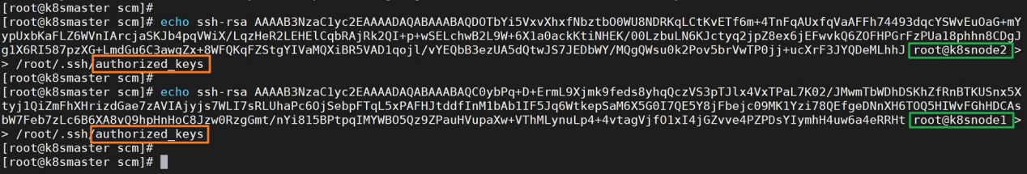

**验证一下，从任何节点，分别登录其他服务器，看是否需要输入密码，如果不需要输入密码，互信免密就成功了。**

1. **更换yum国内源，推荐配阿里源：**

# **wget -O /etc/yum.repos.d/CentOS-Base.repo http://mirrors.aliyun.com/repo/Centos-7.repo**

--2023-05-26 19:45:15-- http://mirrors.aliyun.com/repo/Centos-7.repo

Resolving mirrors.aliyun.com (mirrors.aliyun.com)... 140.207.236.230, 140.207.236.146, 140.207.236.232, ...

Connecting to mirrors.aliyun.com (mirrors.aliyun.com)|140.207.236.230|:80... connected.

HTTP request sent, awaiting response... 200 OK

Length: 2523 (2.5K) [application/octet-stream]

Saving to: ‘/etc/yum.repos.d/CentOS-Base.repo’

100%[========================================================>] 2,523 --.-K/s in 0.002s

2023-05-26 19:45:15 (344 MB/s) - ‘/etc/yum.repos.d/CentOS-Base.repo’ saved [2523/2523]

网易源：

# **wget -O /etc/yum.repos.d/CentOS-Base163.repo http://mirrors.163.com/.help/CentOS7-Base-163.repo**

--2023-05-26 19:46:47-- http://mirrors.163.com/.help/CentOS7-Base-163.repo

Resolving mirrors.163.com (mirrors.163.com)... 101.71.33.11

Connecting to mirrors.163.com (mirrors.163.com)|101.71.33.11|:80... connected.

HTTP request sent, awaiting response... 200 OK

Length: 1572 (1.5K) [application/octet-stream]

Saving to: ‘/etc/yum.repos.d/CentOS-Base163.repo’

100%[==========================================================>] 1,572 --.-K/s in 0.002s

2023-05-26 19:46:47 (794 KB/s) - ‘/etc/yum.repos.d/CentOS-Base163.repo’ saved [1572/1572]

清理yum缓存，并生成新的缓存。

# yum clean all

# yum makecache

# yum check-update

更新yum源检查是否生效

# yum update

# yum install -y conntrack ipvsadm ipset jq sysstat curl iptables libseccomp

若更新 yum 源不更新内核：直接在 yum 的命令后面加如下的参数。

# yum --exclude=kernel* update

**更新后的内核版本如下**

Kernel: Linux 3.10.0-1160.90.1.el7.x86_64 Architecture: x86-64

1. **配置虚拟机IP**

# vim /etc/sysconfig/network-scripts/ifcfg-ens33

*****

BOOTPROTO="dhcp" # "static" 这修改成静态

NAME="ens33"

UUID="c43b3a64-0737-496d-b291-0006ad1db97a"

DEVICE="ens33"

ONBOOT="yes"

修改如下：

ONBOOT="yes"

IPADDR=192.168.59.133

NETMASK=255.255.255.0

GATEWAY=192.168.59.2

**重新启动网卡**

# systemctl restart NetworkManager # systemctl stop NetworkManager

# systemctl restart network

# service network restart # systemctl disable NetworkManager

查看Gateway 执行如下指令：

# route -n|grep '^0.0.0.0' | awk '{print $2}'

# route -n

# kernel IP routing table

Destination Gateway Genmask Flags Metric Ref Use Iface

0.0.0.0 192.168.59.2 0.0.0.0 UG 100 0 0 ens33

192.168.59.0 0.0.0.0 255.255.255.0 U 100 0 0 ens33

192.168.122.0 0.0.0.0 255.255.255.0 U 0 0 0 virbr0

# ip route show

default via 192.168.59.2 dev ens33 proto static metric 100

192.168.59.0/24 dev ens33 proto kernel scope link src 192.168.59.151 metric 100

192.168.122.0/24 dev virbr0 proto kernel scope link src 192.168.122.1

# ip address

# ping 14.215.177.39

# ping www.baidu.com

# cat /etc/resolv.conf

# Generated by NetworkManager

nameserver 223.5.5.5

nameserver 119.29.29.29

nameserver 114.114.114.114

**给网卡** ifcfg-ens33 **添加DNS**

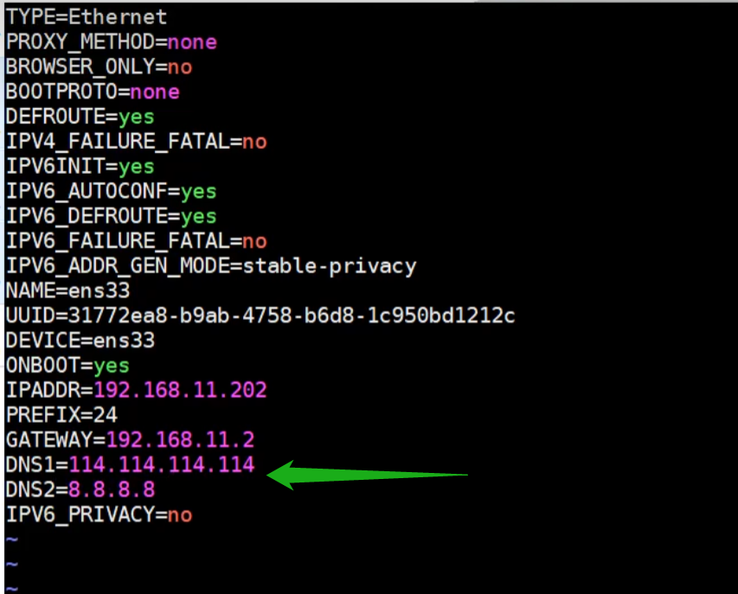

1. **准备环境**

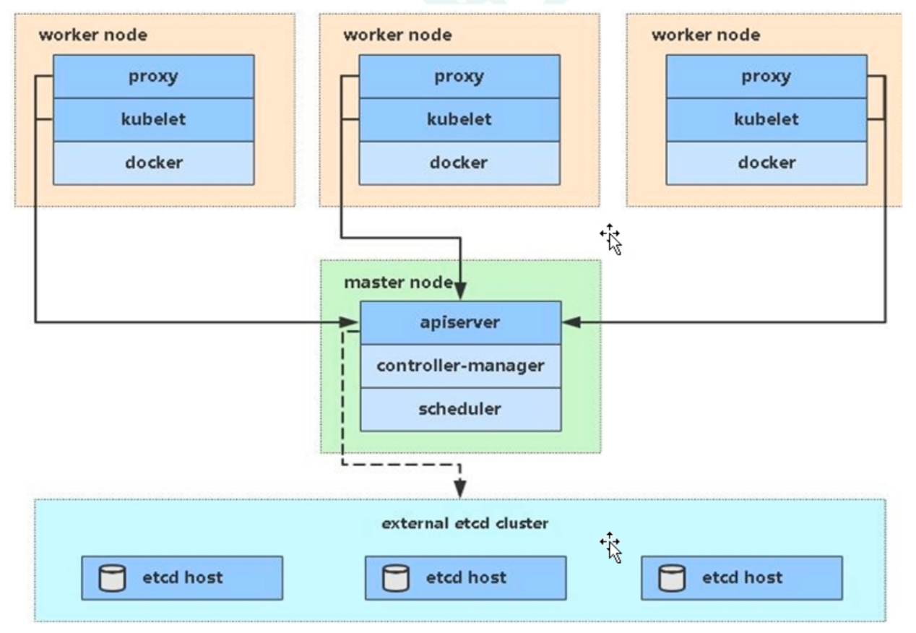

**系统初始化操作**

7.1 关闭防火墙

# systemctl status firewalld

# systemctl stop firewalld

# systemctl disable firewalld #禁止开机启动

7.2 关闭selinux:

# sed -i 's/enforcing/disabled/' /etc/selinux/config #永久

# setenforce 0 #临时

查看selinux状态

# sestatus #查看是否生效

# getenforce #查看是否生效

**7.3 关闭swap:**

# sed -i 's/.*swap.*/#&/' /etc/fstab #注释掉swap这一行，永久关闭。

# swapoff -a #临时

# free -lhgt #查看分区空间

**7.4 修改主机名:**

hostnamectl set-hostname <hostname>

# hostnamectl set-hostname k8smaster

**7.5 在 master 主机添加 hosts，节点机上无需执行。**

# cat >> /etc/hosts << EOF

192.168.59.133 k8smaster

192.168.59.134 k8snode1

192.168.59.135 k8snode2

EOF

**7.6 修改内核参数，将桥接的 IPv4流量传递到iptables的链，所有节点服务器都要执行。**

# cat > /etc/sysctl.d/k8s.conf << EOF

net.bridge.bridge-nf-call-ip6tables = 1

net.bridge.bridge-nf-call-iptables = 1

EOF

# cat /etc/sysctl.d/k8s.conf #查看配置参数

# sysctl --system #立即生效

7.7 设置时间同步

# yum install ntpdate -y

# ntpdate time.windows.com

# ntpdate ntp.aliyun.com

# 配置定时同步

echo '*/15 * * * * ntpdate ntp.aliyun.com > /dev/null 2>&1' >> /var/spool/cron/root

crontab -l

1. **所有机器安装Docker/kubeadm/kubelet/kubectl**

Kubernetes默认CRI (容器运行时)为Docker因此先安装Docker。

**8.1 安装Docker**

执行以下命令来列出所有可用的Docker版本

# yum list docker-ce --showduplicates | sort -r

# wget https://mirrors.aliyun.com/docker-ce/linux/centos/docker-ce.repo -O /etc/yum.repos.d/docker-ce.repo

**配置阿里Docker源：**

# cat >> /etc/yum.repos.d/docker.repo <<EOF

[docker-repo]

name=Docker Repository

baseurl=http://mirrors.aliyun.com/docker-engine/yum/repo/main/centos/7

enabled=1

gpgcheck=0

EOF

# yum install -y docker-ce docker-ce-cli <http://containerd.io>

# yum install -y docker-ce-18.06.1.ce-3.el7

设置 **Docker** 加速器

cat > /etc/docker/daemon.json << EOF

{

"exec-opts": ["native.cgroupdriver=systemd"],

"registry-mirrors": ["https://kfwkfulq.mirror.aliyuncs.com",

"https://2lqq34jg.mirror.aliyuncs.com",

"https://pee6w651.mirror.aliyuncs.com","https://b9pmyelo.mirror.aliyuncs.com","https://rrnv06ig.mirror.aliyuncs.com","https://reg-mirror.qiniu.com","https://docker.mirrors.ustc.edu.cn","https://registry.docker-cn.com",

"http://hub-mirror.c.163.com"]

}

EOF

**# systemctl restart containerd # systemctl status containerd**

service docker start

systemctl status docker.service

systemctl daemon-reload && systemctl restart docker && systemctl enable docker

**8.2 在所有节点服务器上安装cri-docker的包**

项目下载路径如下：

<https://github.com/Mirantis/cri-dockerd/releases/tag/v0.3.2>

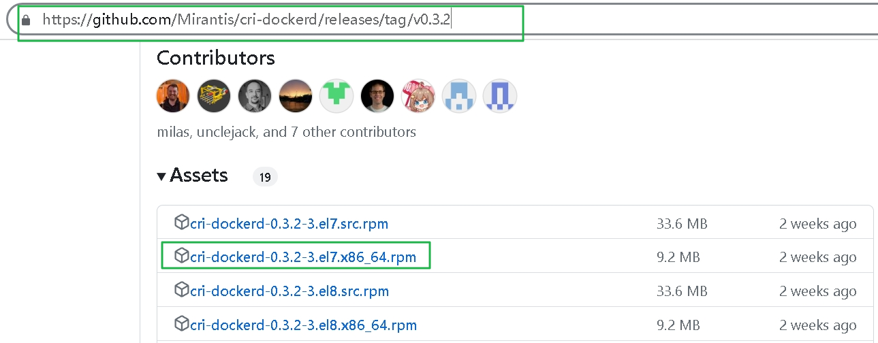

通过rpm指令安装

# rpm -ivh cri-dockerd-0.3.2-3.el7.x86_64.rpm

Preparing... ################################# [100%]

Updating / installing...

1:cri-dockerd-3:0.3.2-3.el7 ################################# [100%]

#

修改配置cri-docker使用国内镜像

/usr/lib/systemd/system/cri-docker.service

sed -i "s#^ExecStart.*#ExecStart=/usr/bin/cri-dockerd --network-plugin=cni --pod-infra-container-image=registry.aliyuncs.com/google_containers/pause:3.9#" /usr/lib/systemd/system/cri-docker.service

启动服务

systemctl daemon-reload && systemctl start cri-docker && systemctl enable cri-docker

# 如果没有报错那cri没问题，否则需要检查。

查看服务状态

systemctl status cri-docker

systemctl is-active docker cri-docker #检查docker、cri-docker状态

**8.3 添加阿里云YUM软件源**

cat > /etc/yum.repos.d/kubernetes.repo << EOF

[kubernetes]

name=kubernetes

baseurl=https://mirrors.aliyun.com/kubernetes/yum/repos/kubernetes-el7-x86_64

enabled=1

gpgcheck=1

repo_gpgcheck=1

gpgkey=https://mirrors.aliyun.com/kubernetes/yum/doc/yum-key.gpg

<https://mirrors.aliyun.com/kubernetes/yum/doc/rpm-package-key.gpg>

EOF

**8.4 安装kubeadm、kubelet和kubectl**

**yum list kubeadm --showduplicates | sort -r**

**yum install -y kubectl-1.18.0 kubelet-1.18.0 kubeadm-1.18.0**

yum install -y kubeadm-1.26.3 kubectl-1.26.3 kubelet-1.26.3

**yum install -y kubelet-1.25.2 kubeadm-1.25.2 kubectl-1.25.2**

**yum install -y kubelet-1.25.10 kubeadm-1.25.10 kubectl-1.25.10**

yum install -y kubelet kubeadm kubectl

**yum downgrade kubelet-1.24.1 kubeadm-1.24.1 kubectl-1.24.1 #降级安装版本**

****systemctl status kubelet.service****

****systemctl enable kubelet #设置成开机启动****

****systemctl start kubelet****

****kubelet --version****

****ps -ef|grep kube-apiserver****

****ps -ef|grep kube-kubelet****

****ps -ef|grep kube-scheduler****

systemctl status kubelet | journalctl -xe

journalctl -u kubelet --no-pager #查看启动报错日志，--no-pager 参数可以一次性输出日志。

journalctl -xefu kubelet

journalctl -u kubelet -f

journalctl -xe -u kubelet

查看kubeadm使用的镜像

kubeadm config images list

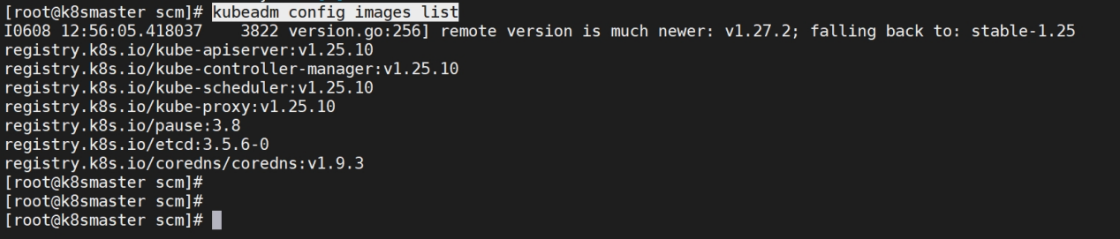

**8.5 部署kubernets Master**

在**59.133** (**Master**) 节点上执行

kubeadm init --apiserver-advertise-address=**192.168.59.133** --image-repository registry.aliyuncs.com/google_containers --kubernetes-version v1.27.2 --service-cidr=10.96.0.0/12 --pod-network-cidr=10.244.0.0/16

**注意**：--kubernetes-version 使用机器上安装的真实版本

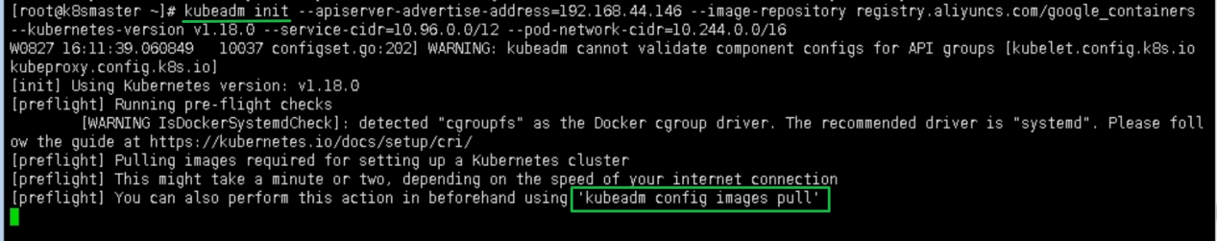

**kubeadm config imgaes pull** 拉取镜像，会有如下的提示信息，说明镜像拉取成功。

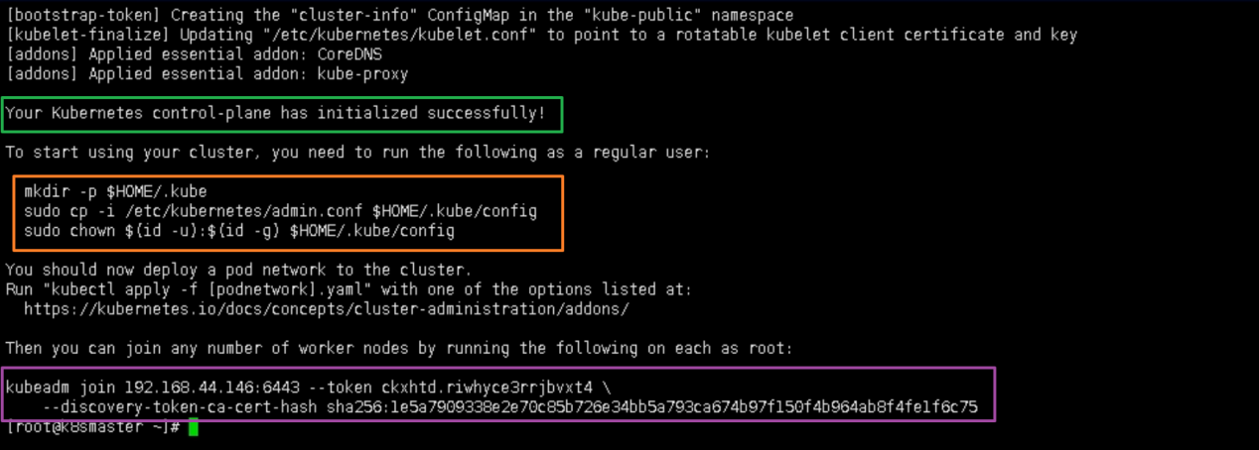

kubeadm join 192.168.*.* 在node 节点上执行，向集群添加新节点。

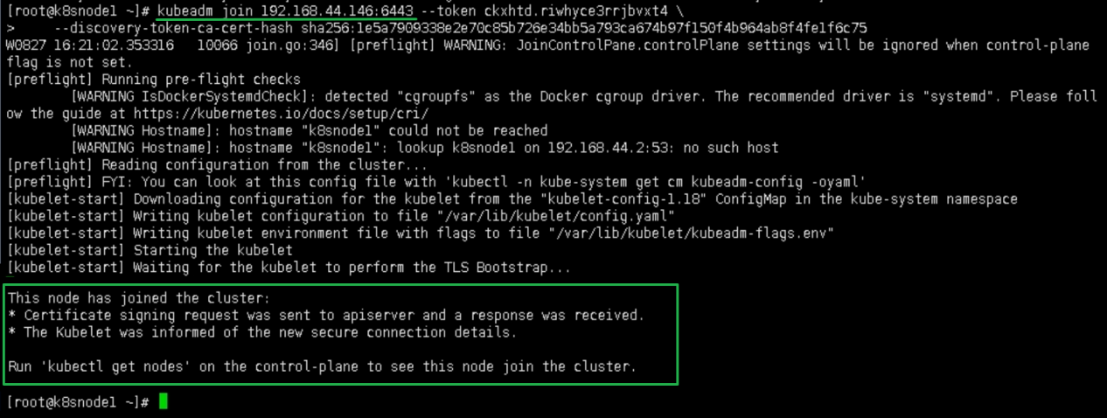

**kubeadm init初始化报错解决，可以尝试使用下面的指令执行。**

# kubeadm init --image-repository registry.aliyuncs.com/google_containers --ignore-preflight-errors=Swap

**kubeadm init 参数说明**

|  |  |  |
| --- | --- | --- |
| **参数值** | **说明** | **备注** |
| --kubernetes-version | v1.26.2 | 初始化时指定k8s的版本号 |
| --apiserver-advertise-address | 192.168.59.138 | 监听的本机地址 |
| --service-cidr | 10.96.0.0/12 | 指定集群虚拟网络 |
| --pod-network-cidr | 10.244.0.0/16 | 指定pod容器网络 |
| --control-plane-endpoint | 192.168.59.138:6443 |  |
| --image-repository | registry.aliyuncs.com/google_containers | 指定下载镜像 |
| --ignore-preflight-errors | Swap | 忽略swap错误 |

由于默认拉取镜像地址 k8s.gcr.io 国内无法访问，这里指定阿里云镜像仓库地址。

查看国内镜像

# kubeadm config images list --image-repository registry.aliyuncs.com/google_containers

W0527 14:18:35.291846 65668 version.go:104] could not fetch a Kubernetes version from the internet: unable to get URL "https://dl.k8s.io/release/stable-1.txt": Get "https://dl.k8s.io/release/stable-1.txt": dial tcp: lookup dl.k8s.io on [::1]:53: read udp [::1]:44172->[::1]:53: read: connection refused

W0527 14:18:35.291967 65668 version.go:105] falling back to the local client version: v1.27.2

W0527 14:18:35.292329 65668 images.go:80] could not find officially supported version of etcd for Kubernetes v1.27.2, falling back to the nearest etcd version (3.5.7-0)

registry.aliyuncs.com/google_containers/kube-apiserver:v1.27.2

registry.aliyuncs.com/google_containers/kube-controller-manager:v1.27.2

registry.aliyuncs.com/google_containers/kube-scheduler:v1.27.2

registry.aliyuncs.com/google_containers/kube-proxy:v1.27.2

registry.aliyuncs.com/google_containers/pause:3.9

registry.aliyuncs.com/google_containers/etcd:3.5.7-0

registry.aliyuncs.com/google_containers/coredns:v1.10.1

所有节点拉取

# kubeadm config images pull --kubernetes-version=v1.27.2 --image-repository registry.aliyuncs.com/google_containers --cri-socket unix:///var/run/cri-dockerd.sock

**初始化master节点（仅在master节点执行）**

kubeadm init --apiserver-advertise-address=192.168.59.133 --kubernetes-version=v1.27.2 --pod-network-cidr=10.244.0.0/16 --service-cidr=10.96.0.0/12 --token-ttl=0 --cri-socket=unix:///var/run/cri-dockerd.sock --image-repository registry.aliyuncs.com/google_containers --upload-certs --ignore-preflight-errors=all

**常见问题：**error: “Failed to load kubelet config file” err=“failed to load Kubelet config file /var/lib/kubelet/config.yaml”

**解决方法是：**添加启动进程接口路径。

kubeadm init --image-repository registry.cn-hangzhou.aliyuncs.com/google_containers --cri-socket=unix:///var/run/cri-dockerd.sock

kubeadm init --image-repository registry.aliyuncs.com/google_containers --ignore-preflight-errors=Swap --cri-socket=unix:///var/run/cri-dockerd.sock

kubeadm reset -f

列出下载的镜像

# kubeadm config images list --image-repository registry.aliyuncs.com/google_containers

#

kubeadm init --apiserver-advertise-address=192.168.59.133 --kubernetes-version=v1.26.3 --pod-network-cidr=10.244.0.0/16 --service-cidr=10.96.0.0/12 --image-repository registry.aliyuncs.com/google_containers --upload-certs --ignore-preflight-errors=all

kubeadm init --config=kubeadm-config.yaml --experimental-upload-certs | tee kubeadm-init.log

使用kubectl工具，配置kube的环境变量。

mkdir -p $HOME/.kube

sudo cp -i /etc/kubernetes/admin.conf $HOME/.kube/config

sudo chown $(id -u):$(id -g) $HOME/.kube/config

kubectl get nodes #获取节点状态

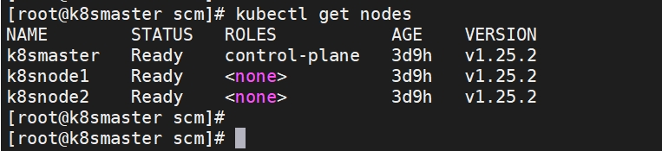

加入 kubernetes Node

在Node 服务器59.134、59.135 节点上执行，向集群添加新节点，执行在 kubeadm init 输出的 kubeadm join 命令：

kubeadm join 192.168.59.133:6443 --token 1zobjk.teg9wbpovoa3xkul --discovery-token-ca-cert-hash sha256:1dc06b47eec661408e7a3093e01b40d3436e7a7118509e6c0a274567a01b5964

默认token有效期为24小时，当过期之后，该token就不可用了。这时就需要重新创建token了，执行如下：

kubeadm token create --print-join-command

**步骤在前 》》部署 CNI 网络插件**

wget <https://raw.githubusercontent.com/coreos/flannel/master/Documentation/kube-flannel.yml>

**需要修改 kube-flannel.yml 源文件，修改对比如下几行。**

# diff kube-flannel.yml.bak0603 kube-flannel.yml

**修改好 kube-flannel.yml 配置文件后，安装Flannel网络插件。**

# kubectl apply -f kube-flannel.yml

namespace/kube-flannel unchanged

clusterrole.rbac.authorization.k8s.io/flannel unchanged

clusterrolebinding.rbac.authorization.k8s.io/flannel unchanged

serviceaccount/flannel unchanged

configmap/kube-flannel-cfg unchanged

daemonset.apps/kube-flannel-ds configured

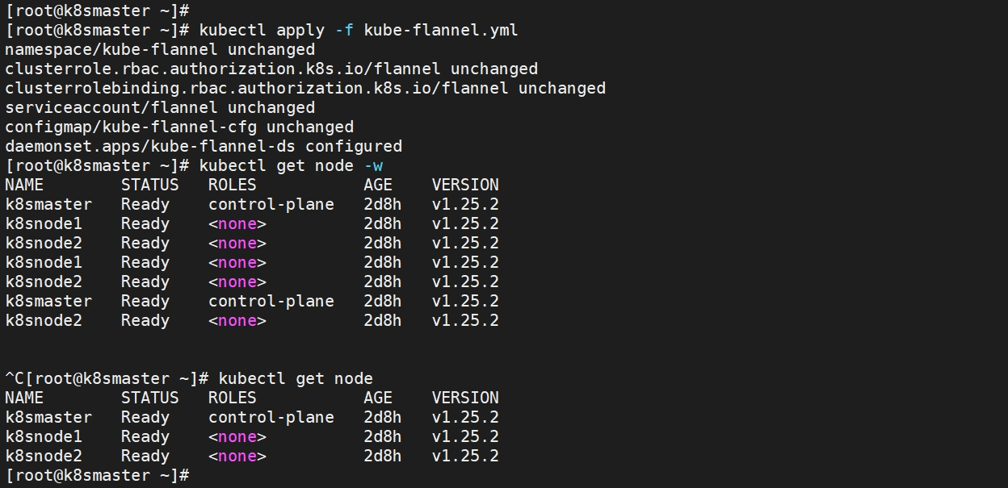

默认镜像地址无法服务，sed 命令修改为docker hub 镜像仓库。

kubectl apply -f <https://raw.githubusercontent.com/coreos/flannel/master/Documentation/kube-flannel.yml>

kubectl get pods -n kube-system

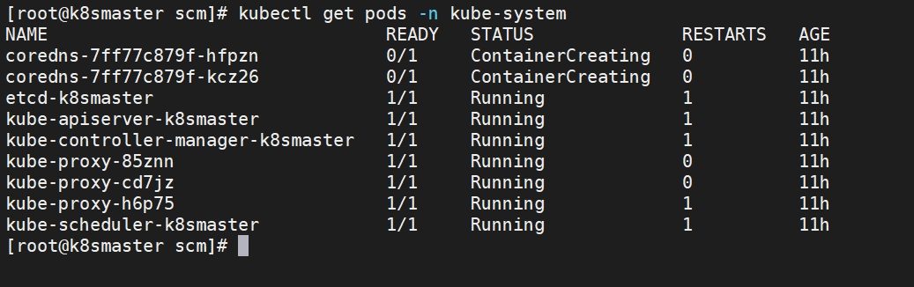

kubectl get pod --all-namespaces -o wide

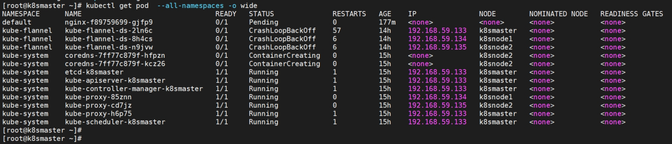

kubectl get pod -o wide

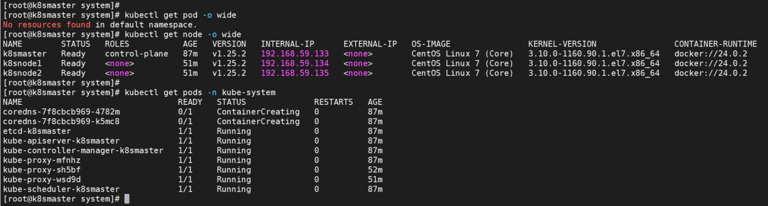

查看pod是否正常、节点是否ready。

kubectl get pod -n kube-system

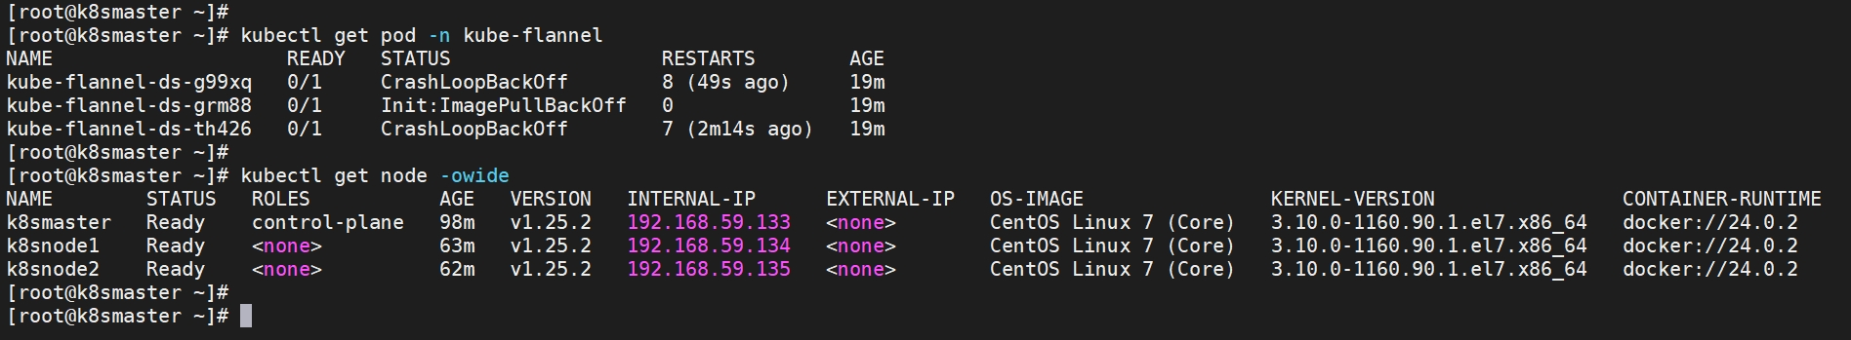



kubectl describe node #检查日志显示

kubectl describe node 192.168.59.133 |grep cidr #检查日志显示的节点*.*.59.133的cidr

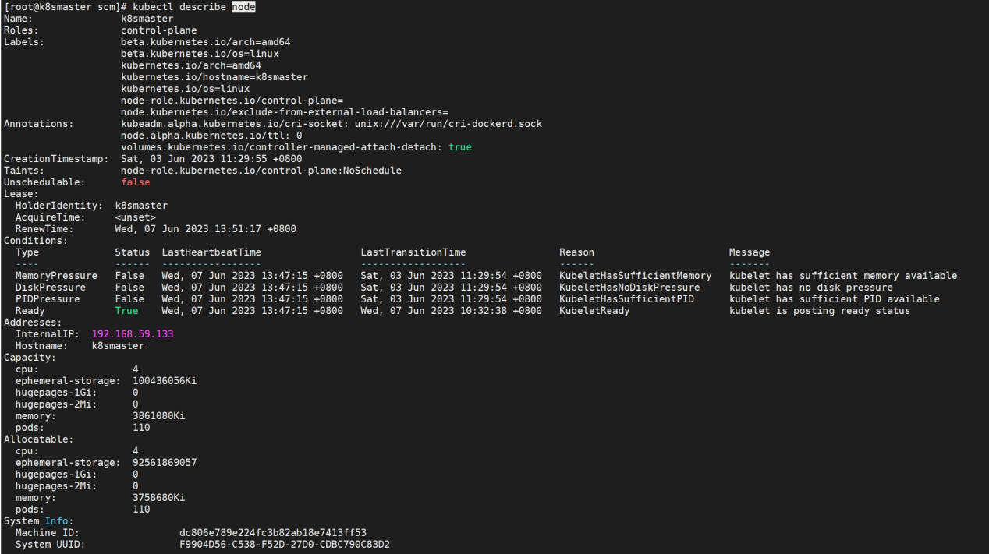

确定 coredns 这两个 pod 处于哪个 node 上

kubectl get pods coredns-7f8cbcb969-sbgmq -n kube-system -o wide

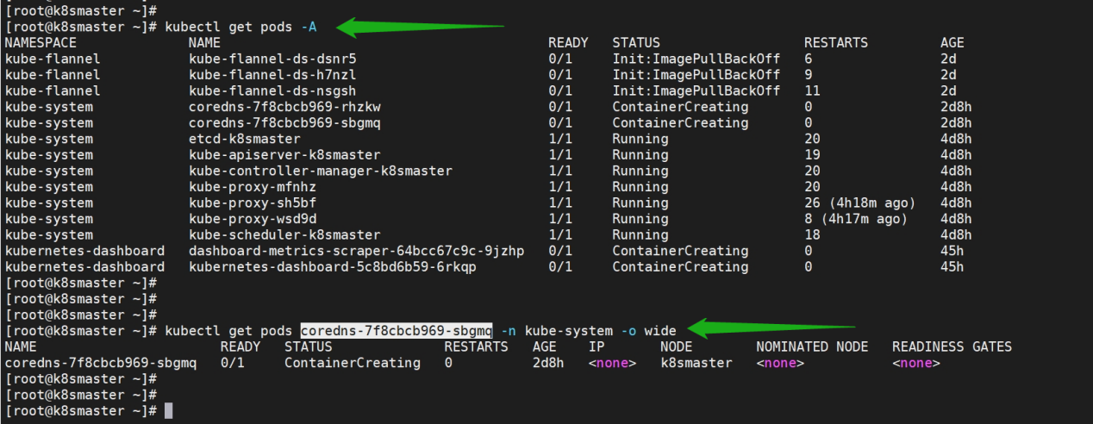

之后查看coredns所需镜像

kubectl get pods coredns-7f8cbcb969-sbgmq -n kube-system -o yaml | grep image

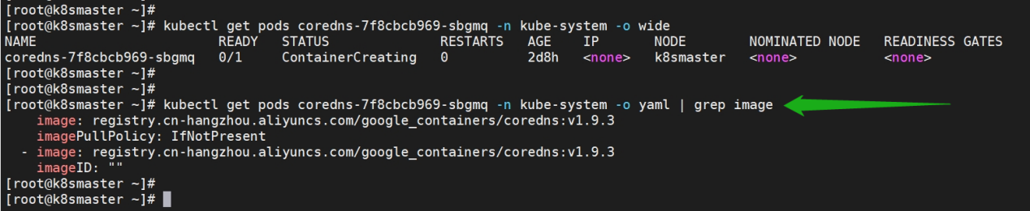

登录coredns所在的node机器，进行手动拉去镜像。

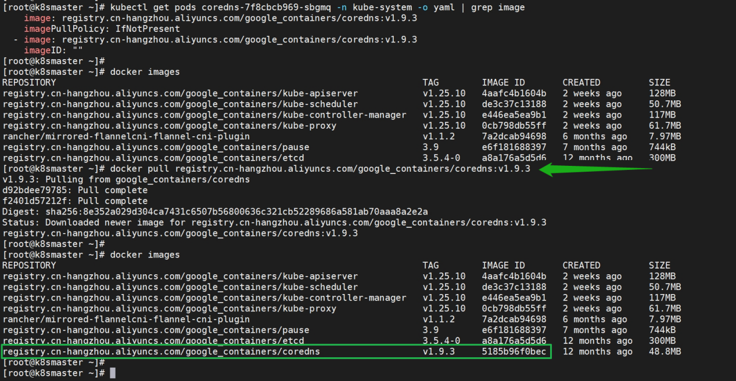

使用describe查看错误信息

kubectl describe pods -n kube-system coredns-7f8cbcb969-jrql5

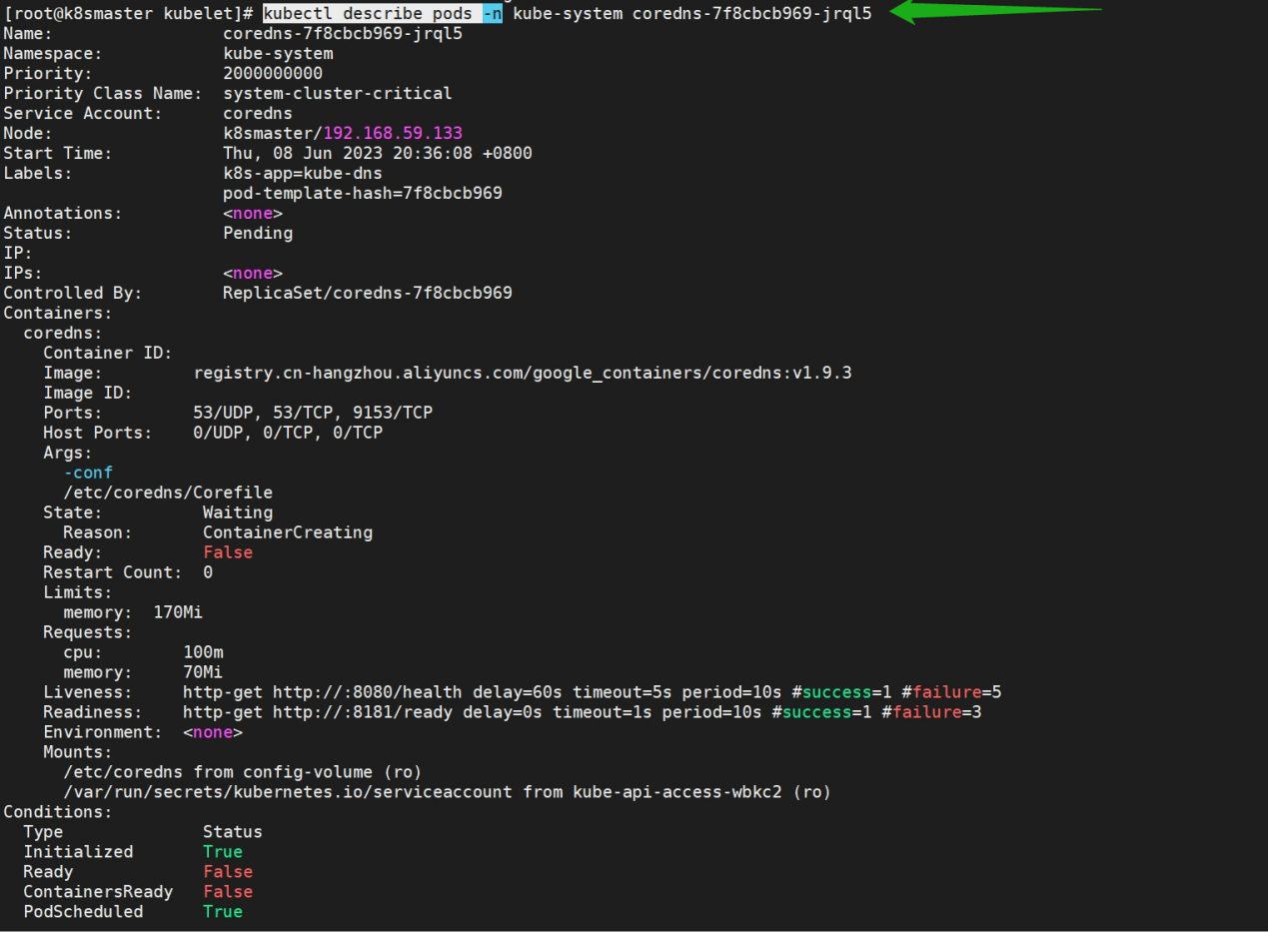

# kubectl describe pods -n kube-flannel kube-flannel-ds-th426

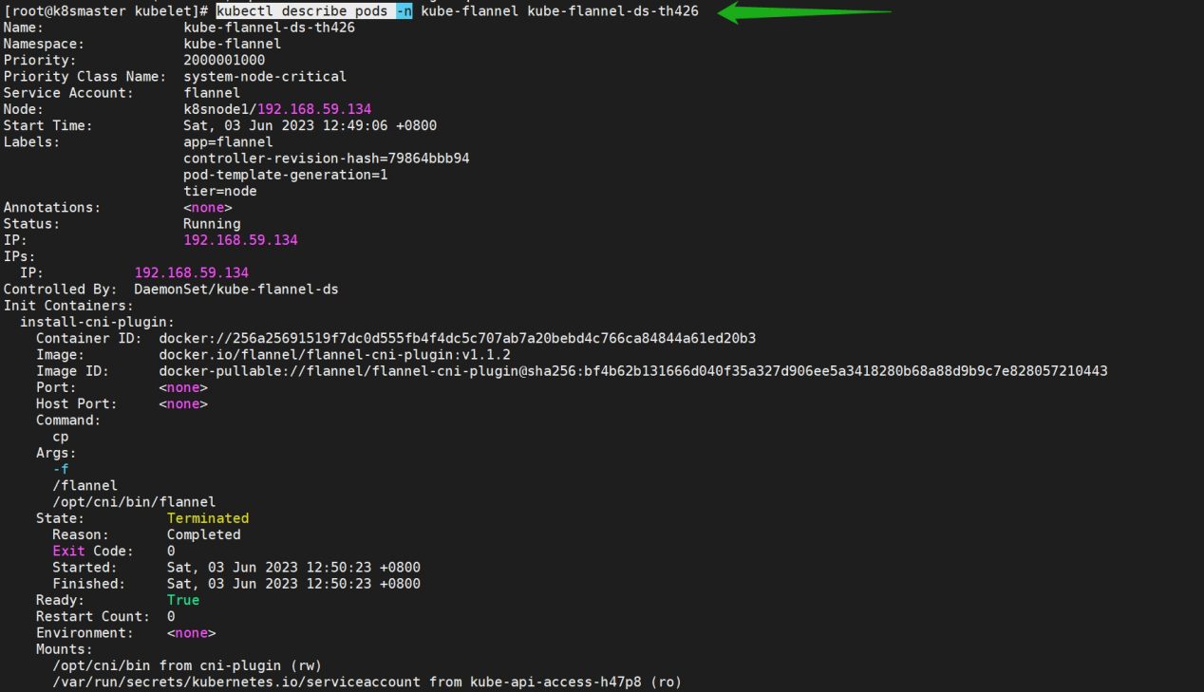

# kubectl describe pods -n kube-system kube-apiserver-k8smaster

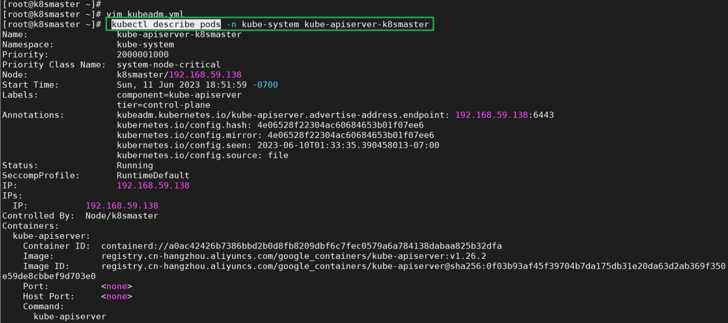

**测试kubernetes集群**

在kubernetes集群中创建一个pod，查看是否正常运行。

kubectl create deployment nginx --image=nginx

kubectl expose deployment nginx --port=80 --type=NodePort

kubectl get pod,svc

docker.socket无法停止的解决方案

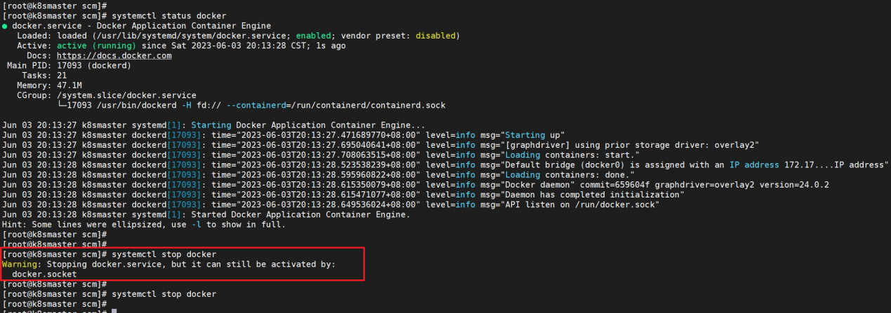

也就是：这是因为除了docker.service单元文件外，还有一个docker.socket单元文件这是用来激活socket的。这个警告意味着如果你在docker服务没有运行的情况下尝试连接docker套接字，那么systemd会自动为你启动docker。

**解决方案**：删除如下的docker.socket单元文件，就能解决。

/lib/systemd/system/docker.socket

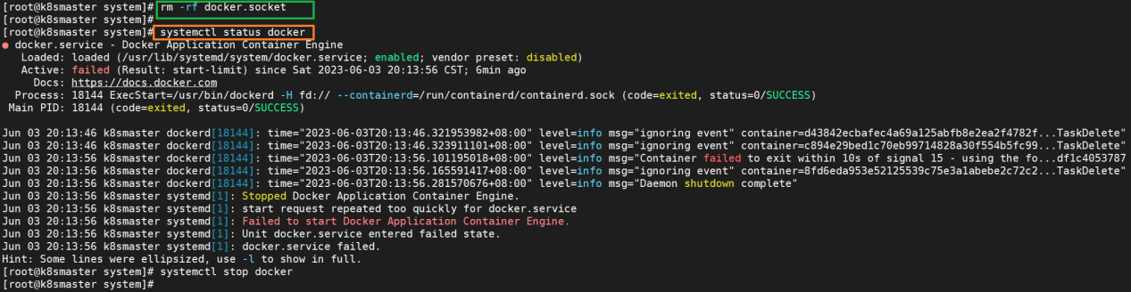

## **Dashboard是基于网页的Kubernetes可视化用户界面**

使用Dashboard将容器应用部署到Kubernetes集群中，也可以对容器应用排错，还能管理集群资源。可以使用Dashboard获取运行在集群中的应用的概览信息，也可以创建或者修改Kubernetes资源( 如Deployment，Job,DaemonSet等等) Dashboard同时展示了Kubernetes集群中的资源状态信息和所有报错信息。

下载页面中看到dashboard v2.7.0是支持Kuberneres 1.25版本的

wget https://raw.githubusercontent.com/kubernetes/dashboard/v2.7.0/aio/deploy/recommended.yaml

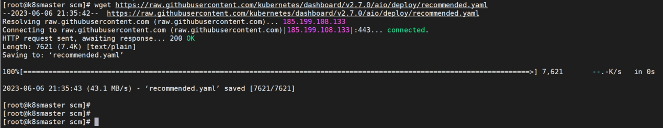

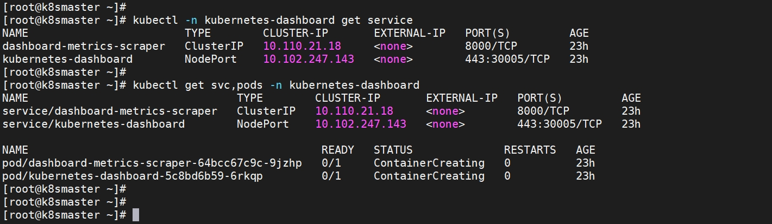

验证，查看pod的状态为running说明dashboard部署成功。

# yum install flannel -y

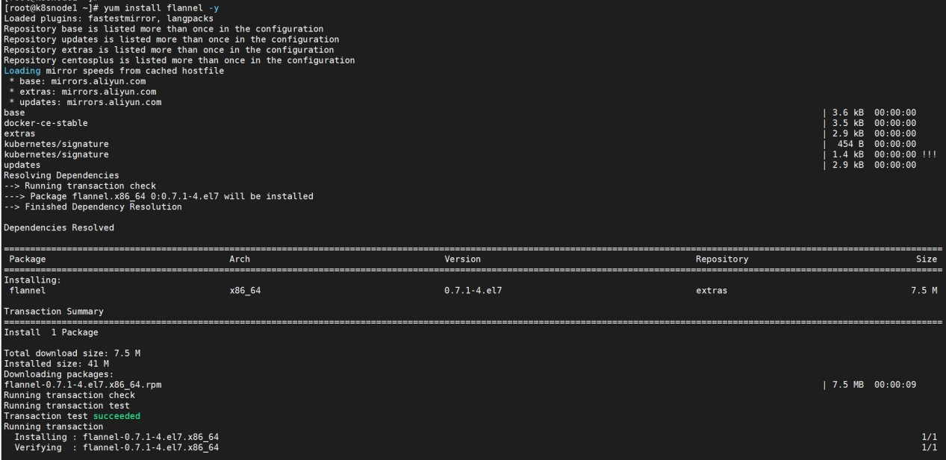

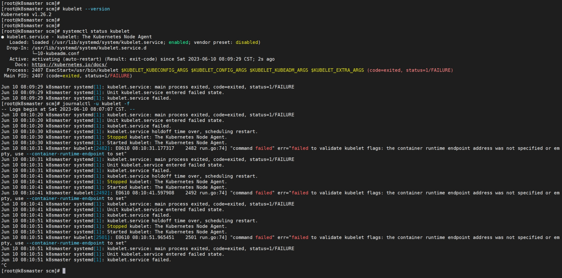

# sysctl -a |grep bridge-nf-call

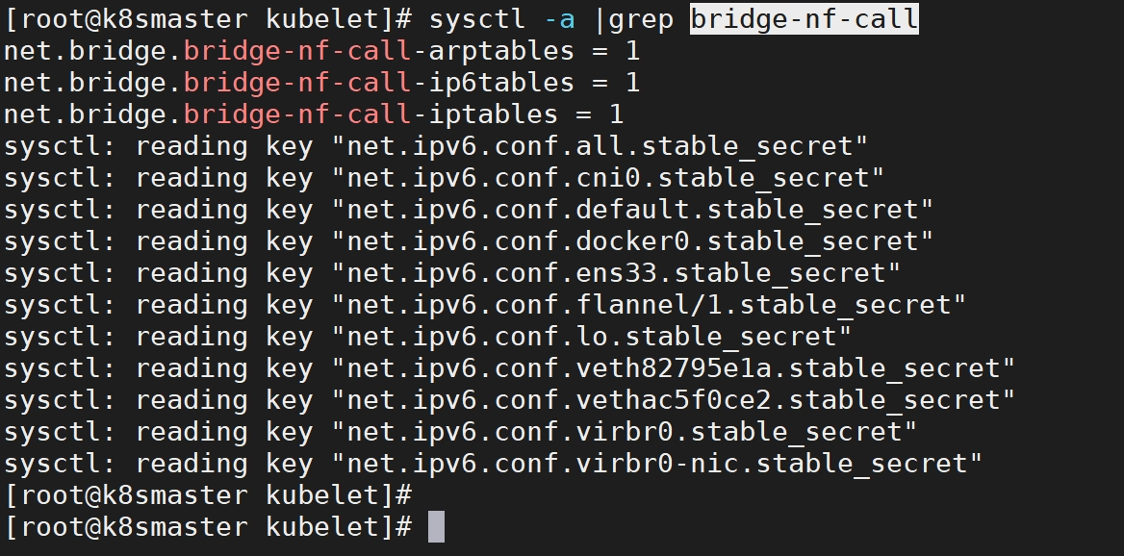

打印初始化时配置，可查看cgroupDriver默认值

# kubeadm config print init-defaults --component-configs KubeletConfiguration

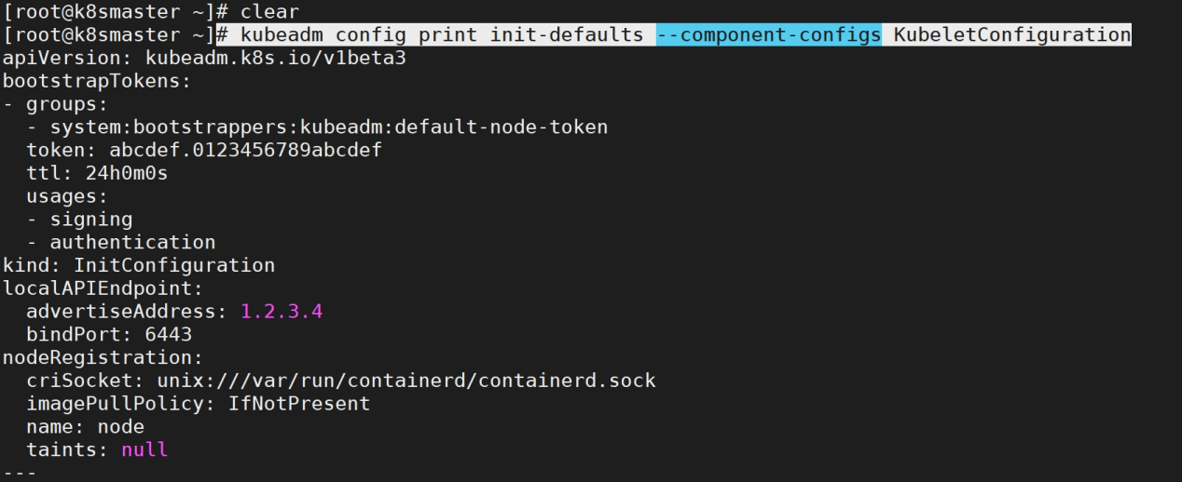

安装依赖

# yum install -y epel-release python36 python36-pip git

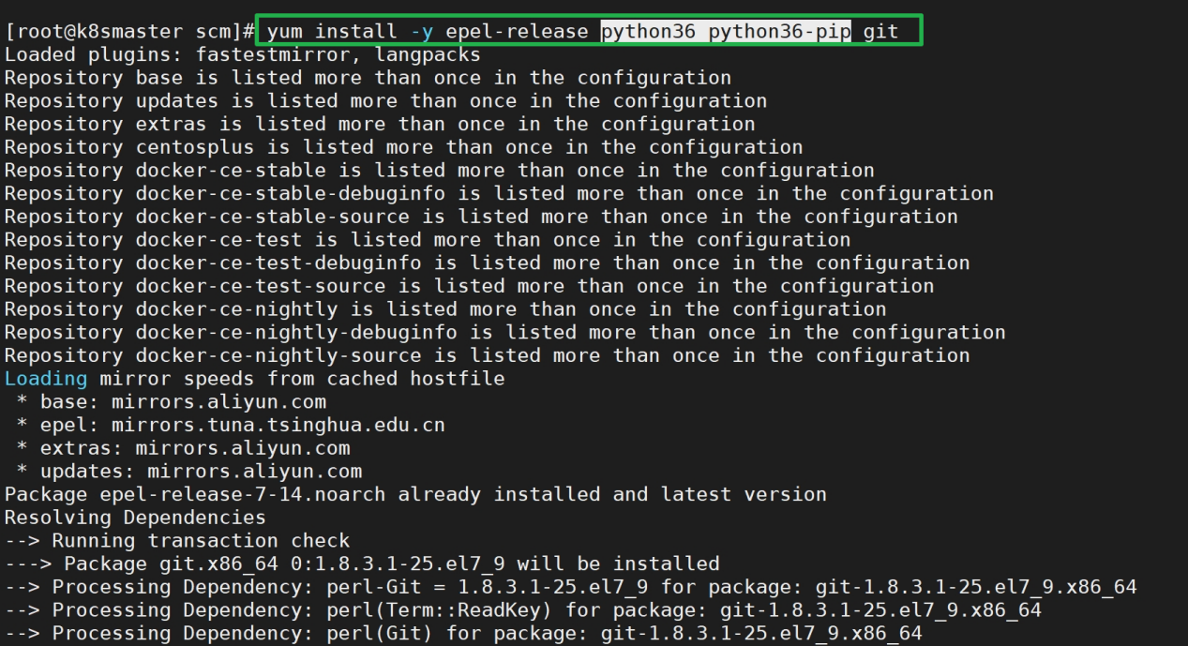

# pip3.6 install setuptools_rust

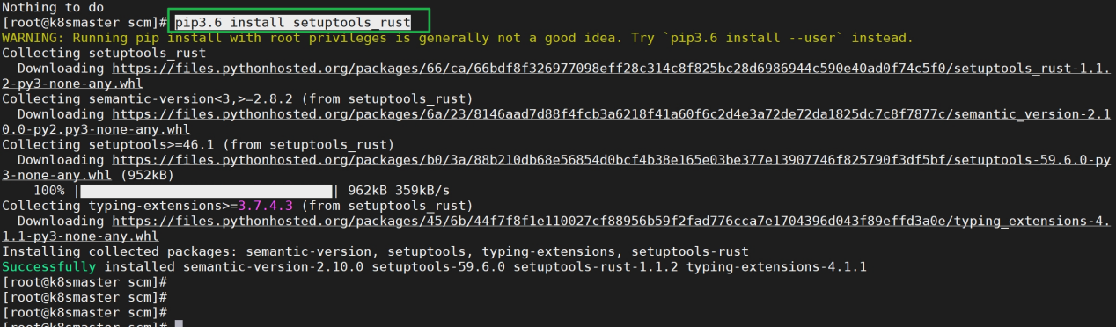

# pip3.6 install --upgrade pip

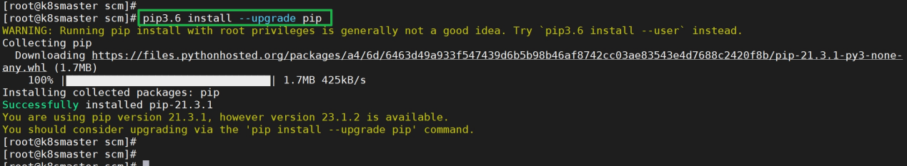

# pip3.6 install ansible

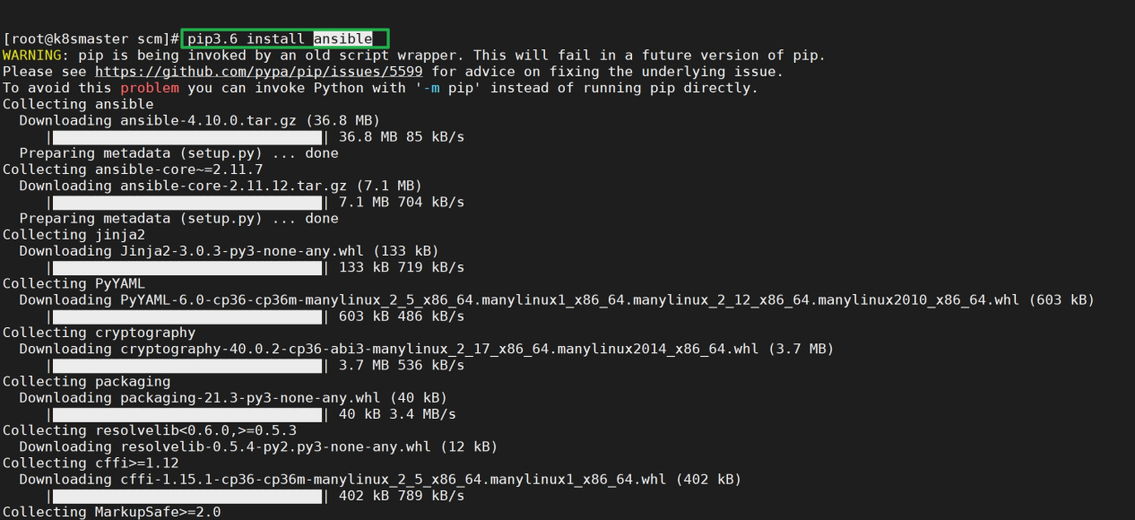

k8s的整体架构如下图所示：

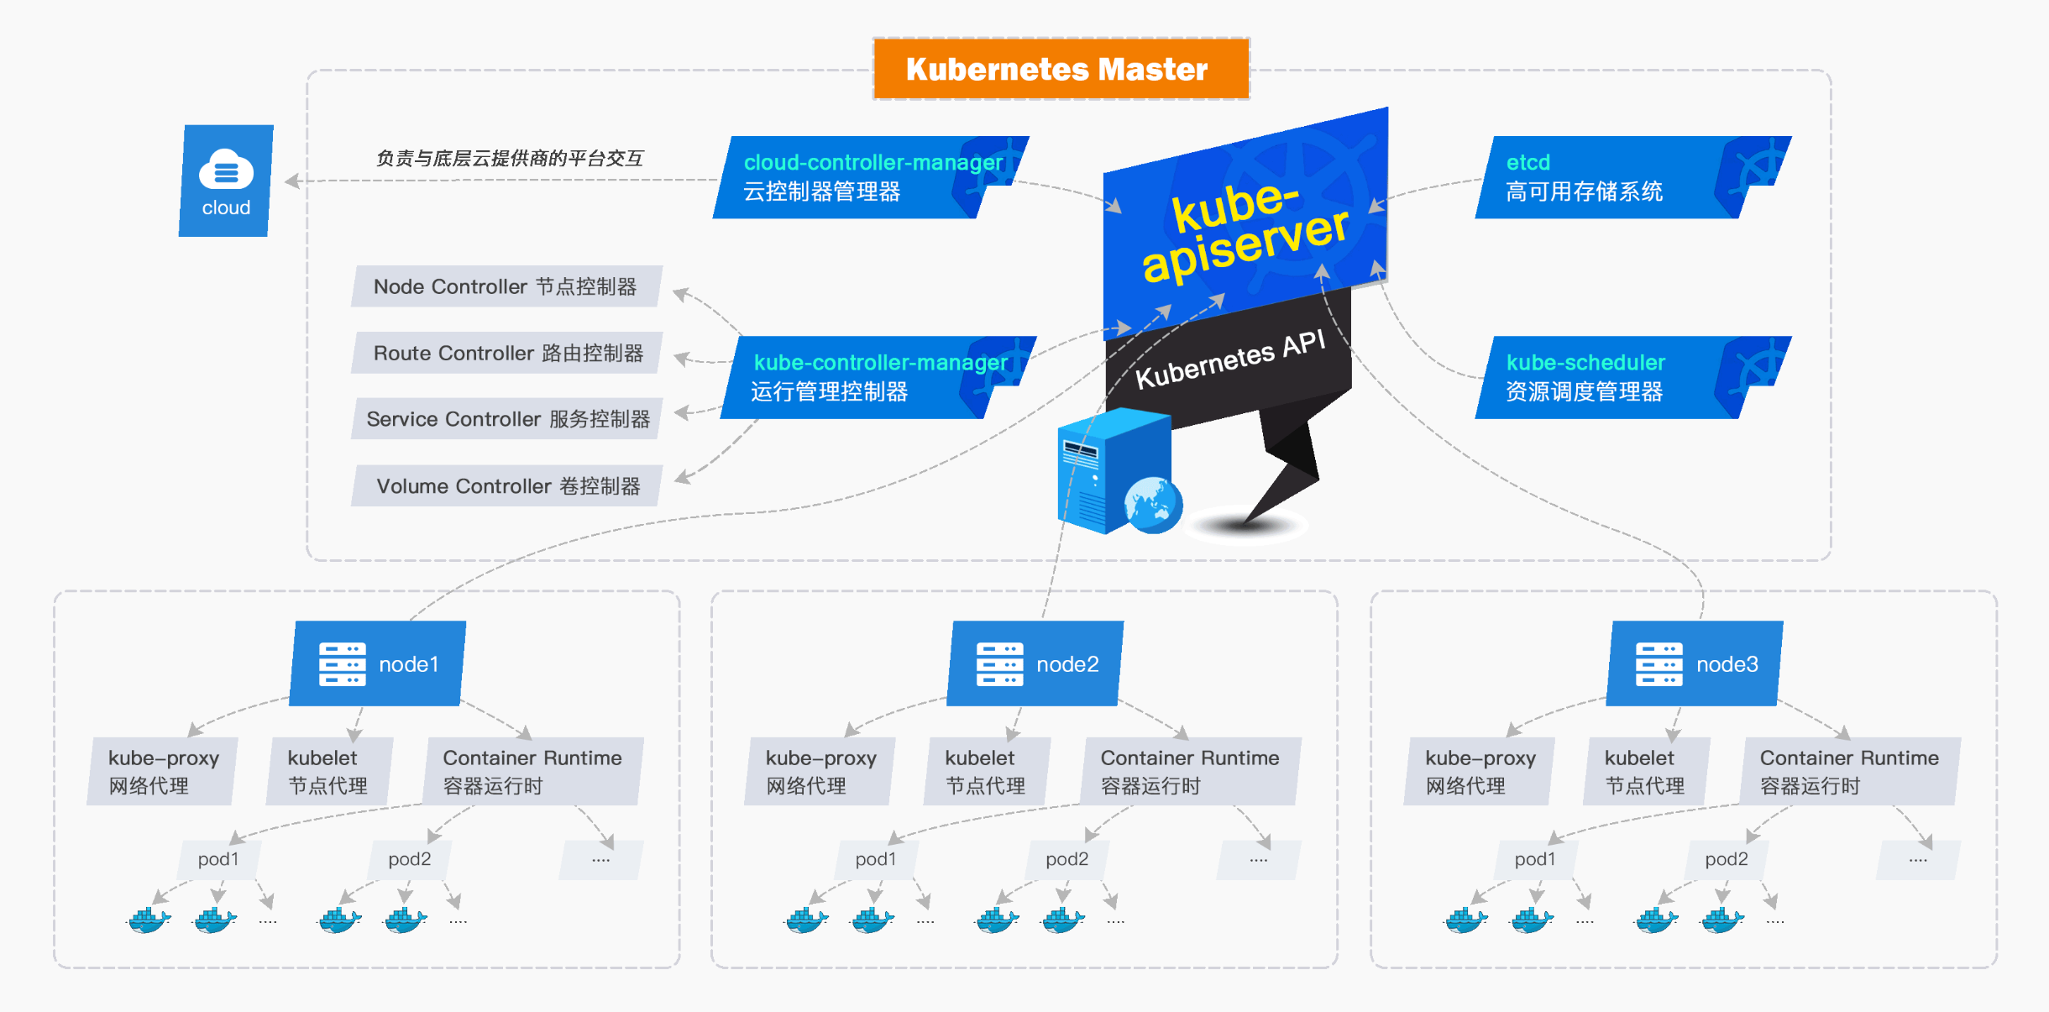

<https://mp.weixin.qq.com/mp/appmsgalbum?__biz=Mzg3NjY2NDQ5MA==&action=getalbum&album_id=2293207738610401281&scene=173&from_msgid=2247484151&from_itemidx=1&count=3&nolastread=1#wechat_redirect>

kubeadm基于docker安装高可用1.26.3版本k8s集群

<https://developer.aliyun.com/article/1230968?spm=a2c6h.14164896.0.0.1fc5d58cm1IHvs>

Kubeadm 快速搭建 k8s v1.24.1 集群（openEuler 22.03 LTS）

<https://developer.aliyun.com/article/1172745?spm=a2c6h.14164896.0.0.1fc5d58cm1IHvs>

k8s 1.26.2基于containerd1.6.18

<https://developer.aliyun.com/article/1230630?spm=a2c6h.14164896.0.0.59d16d139wsgHv>

【kubernetes】从零开始搭建K8S集群

<https://developer.aliyun.com/article/1226818?spm=a2c6h.14164896.0.0.354a6d13pCrAjl>